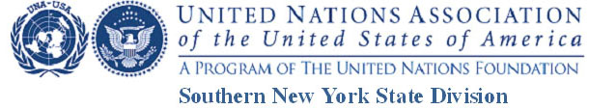

The United Nations Turns 70: Why is it Important?

CHECKLIST OF MATERIALS

Guidelines: These describe the contest eligibility and rules and the due date (April 10).

Video: Upload to YouTube, following instructions in Guidelines.

Application form: Attach the completed application to the email when you send in the
URL of your YouTube Video.

Parent/Legal Guardian or Age 18+ Consent Form: See submission instructions at the bottom of those forms.

Photo / Audio-Visual / Copyright Release Form(s): Attach these to the email when you
send in the URL of your YouTube video (or you may mail them – see the form).

If you have questions, you may email: videocontest@unasouthernny.org Be sure to put “question” In the subject line. We will try to answer in a timely manner.

