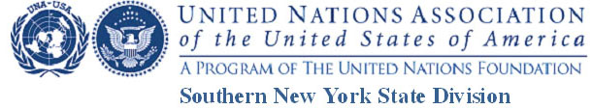

The United Nations turns 70: Why is it important?
Video Contest
Photo/ Audio-Visual / Copyright Release Form

AUTHORIZATION TO USE PHOTOGRAPHS AND/OR AUDIO-VISUAL MATERIALS
OR COPYRIGHTED MATERIALS
(To be completed by anyone whose material is featured in the video.)

I, ___________________________________________, hereby authorize

_________________________________________ (Contestant),
and the United Nations Association of the USA Southern New York State Division and / or project or project sponsors to use, reproduce, and/or publish photographs and/or video that may pertain to me— including my image, likeness and/or voice without compensation. I understand that this material may be used in various publications, public affairs releases, recruitment materials, broadcast public service advertising (PSAs) or for other related endeavors.

If the material is copyrighted, I hereby give permission for its use.

This material may also appear on UNA-USA Southern New York State Division’s or other UNA-USA and its subsidiaries’ Internet Web Pages, newsletters and social media.

This authorization is continuous and may only be revoked by my specific withdrawal of this authorization. Consequently, the Association or project sponsor may publish materials, use my name, photograph, and/or make reference to me in any manner that the Association or project sponsor deems appropriate in order to promote/publicize service opportunities.

Description of Material (Photos/Audio-VisualCopyright):

Signature: ______________________________________________ Date:________________________

Either scan and attach with the email giving the URL of your YouTube and your application or: Mail it to: “The United Nations turns 70: Why is it Important?,” 166 Edgars Lane, Hastings-on-Hudson, NY 10706.

