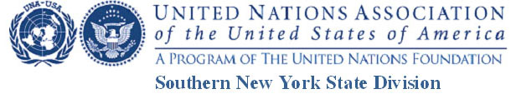

“The United Nations turns 70: Why is it Important?”
Video Contest Application

Please complete this application and email it to: videocontest@unasouthernny.org along with the URL of your YouTube Video (See Guidelines) and the Photo/ Audio-Visual / Copyright Release forms or mail these as described in the Guidelines.

My video is posted at the following YouTube address: _____________________

Name of Student _____________________________________________________

Address: ____________________________________________________________

City _______________________________ County __________________________

Telephone No.: _______________________________________________________

Email address: ________________________________________________________

Student’s School: __________________________________ Grade: ____________

